Test Case
SN | Task | Expected Output | Program Output | Result
1 | 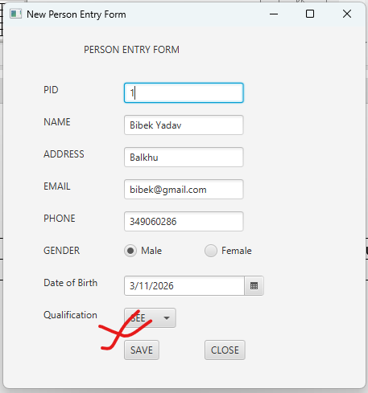 | True | True | PASS
2 |  | True | False | FAIL
3 | 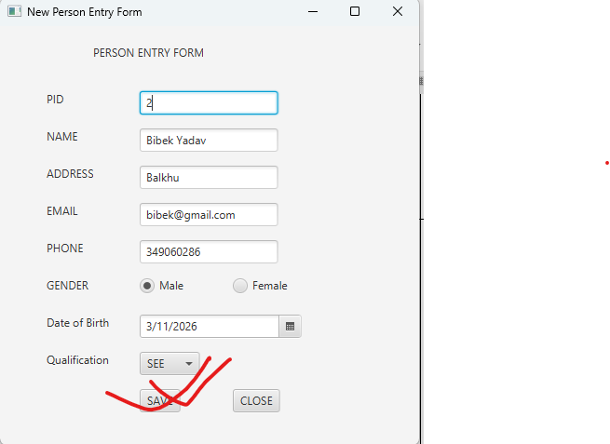 | True | True | PASS

